Design of a CAM to generate a sinusoidal input for a seat vibration setup

In order to take our studies on human body vibration analysis and ergonomics, we proposed to design a CAM which would generate a sinusoidal input to a seat attached to a follower.

Model-

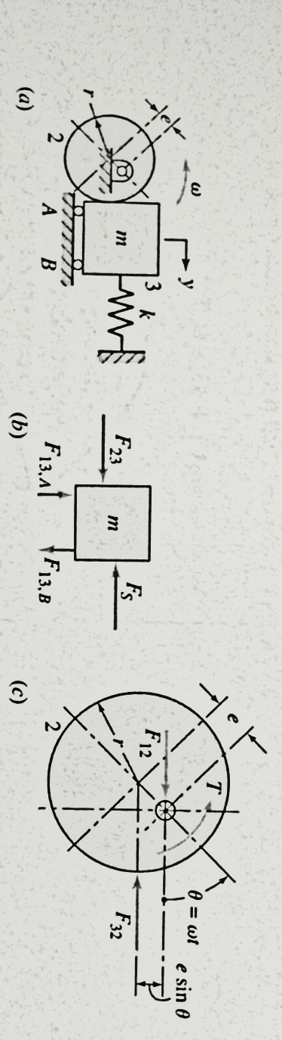

The CAM follower physical model

An eccentric CAM was used as elaborate analytical solutions for its dynamics were available in literature. Also, it would generate the desired sinusoidal oscillatory motion at the output. The CAM would be accompanied by a flat-face follower as this design would be mechanically stronger and less complicated to design and fabricate given the various mechanical elements that are present in a roller follower.

CAM kinematics:

For the dynamic model, we assume that there is no friction and there is a preload P=kδ where δ is the preload compression given to the follower spring during installation.

Summing forces on the follower mass in the y-direction gives:

The force F23 is the contact force between the cam and the follower and hence can have only a positive value. Hence, substitution of the expression for y in the above equation of motion gives

As the maximum probability of contact force becoming zero is at the top of the follower motion (ωt=180°), that value is substituted and F23 is made zero in order to find the value for k (minimum required value is obtained as this is the limiting case).

where

Thesis values are arbitrary but conservative. Hence, substitution of these values gives:

which is a very unrealistic value for a spring.

Let us assume that this spring is available and can be installed. However, we shall see in further calculations that the system parameters are far too unrealistic to be fabricated on the required scale.

Maximum value of F23 occurs at ωt=0, giving

Maximum Torque required

Maximum Power required

These values are far too unrealistic to be implemented as anticipated and cannot be implemented with current constraints. As this is the most ideal model, we can safely assume that any other model would produce similar or worse results. The idea of using a cam for a human seat vibration setup is therefore terminated.

Design of a piston around which current-carrying coil can be wrapped

By our current experimentation with the new mixture of oil and magnetic particles, there has been no change in the damping constant of the system for current varying between 0-2A. Therefore, there is a possibility that the magnetic field experienced by the fluid is not strong enough due to the shielding effect of steel.

Thus, a new design of the system in which the current-carrying coil will be wrapped around the piston will have to be designed.

Points to be taken care of for this design-

1. The groove made in the piston should be of appropriate dimensions so that the piston surface is kept as flat as possible
2. Since there will be wiring coming out of the inside of the cylinder, there should be appropriate arrangements in the sealing made for the same.
3. Overall sealing should be made tight as magnetic nanoparticles are expensive and leakage cannot be afforded

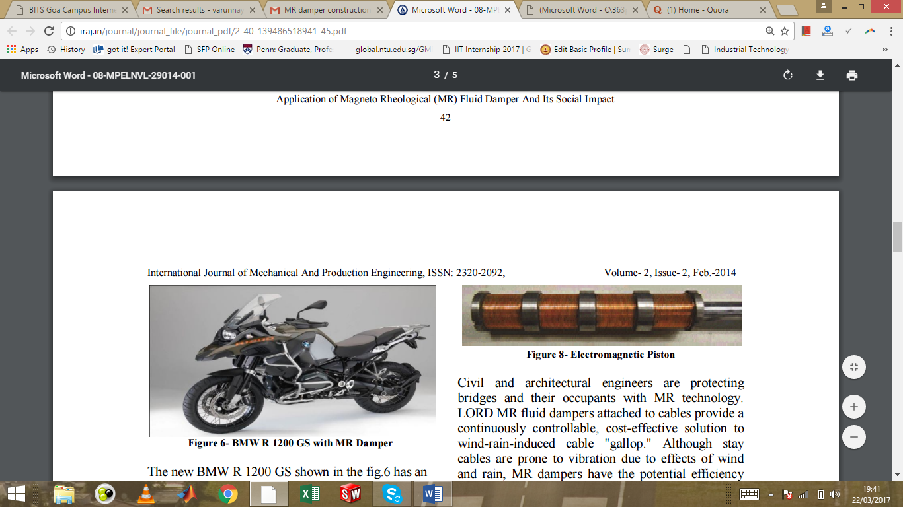

Proposed Piston Design

The project will proceed further with the design, fabrication and testing of the MR Damper equipped with such a piston. However, before we proceed, we will check whether our assumption of shielding is actually true or not by checking the magnetic field developed inside the cylinder with the current design configuration.